Web Development

WEDE5020

Tatum Bruiners

ST10513693

Group 1

Table of Contents
Cover Page …………………………………………………………………………………………………………………………………1
Table of Contents ………………………………………………………………………………………………………………………..2
Organisation Overview 3
Name 3
Brief History 3
Mission and Vision 3
Target Audience 3
Website Goals and Objectives 4
Goals 4
Objectives 4
Key Performance Indicators 4
Current Website Analysis 5
Strengths 5
Weaknesses 5
Areas of Improvement 5
Proposed Website Features and Functionality 6
Features 6
Functionality 6
Design and User Experience 7
Colour scheme 7
Typography 7
Layout and Design 7
User Experience Considerations 8
Low-fidelity Wireframes 8
Technical Requirements 9
Domain Name 9
Hosting 9
Programming Language and Framework 9
Timeline and Milestones 10
Budget 11
Development 11
Domain 11
Hosting 11
Maintenance 11
References 12

Organisation Overview

Name
The organisation chosen for this project is the Society for the Prevention of Cruelty to Animals (SPCA) (Wikipedia Contributors, 2026).

Brief History
The SPCA started in England in 1824 with the goal of protecting animals from cruelty (SPCA International, 2025). As time went on, the organisation expanded to different parts of the world and in 1872, the Cape of Good Hope SPCA was established in South Africa. (NSPCA, 2026).

Mission and Vision
The SPCA focuses on improving the welfare of animals, by preventing cruelty and encouraging people to take responsibility for their pets. Its vision is to create a society where animals are treated with care, respect and protection (NSPCA, 2026).

Target Audience
The SPCA reaches a wide range of people. These include:
- Pet owners who may need advice on how to care for their pets properly
- People who are interested in adopting pets
- Donors and sponsors who want to support animal welfare
- Volunteers who want to help with rescue and care work
- Members of the public who may need to report cases of animal abuse
- Schools and children to build awareness from an early age (SPCA Vereeniging & Vanderbijlpark, 2025)

Website Goals and Objectives

Goals
The main goal of the website is to make it easy for people to take action when needed. This includes donating, adopting animals or reporting cases where animals may be in danger (NSPCA, 2026). Another important goal is to educate users about animal cruelty and responsible pet ownership. The website should help more people understand what the SPCA does and how they can get involved (SPCA International, 2025).

Objectives
To support these goals, the website aims to:
- Increase the number of online donations made over time
- Encourage more people to apply for animal adoption
- Make it easier to report cases of abuse or neglect
- Improve how the public interacts and engages with the organisation (Adobe, 2025)

Key Performance Indicators
The success of the website can be measured in a few practical ways:
- Number of people visiting the website each month
- Amount of donations received online
- Number of adoption applications submitted
- Number of reported animal welfare cases
- Average time users spend on the website (Adobe, 2025)

Current Website Analysis

Strengths
The current website has a number of strengths:
- It is generally easy to navigate
- Information is clear and appears to be updated regularly
- Images are used to support the message and create awareness
- Partnerships with known brands help to build trust with users (Cape of Good Hope SPCA, 2026)

Weaknesses
There are a few areas where the website could improve:
- Layout can feel cluttered, especially when viewed on a mobile device
- There is a lot of information, which may overwhelm users
- More attention is given to donations and reporting than to adoption
- The homepage includes many news updates, which can distract users from important actions (Cape of Good Hope SPCA, 2026)

Areas of Improvement
Based on the weaknesses, a few improvements can be made:
- Simplifying the layout to make the site easier to read across different devices
- Making important buttons like “Donate”, “Adopt” and “Report” stand out more clearly
- Reducing the amount of content on pages to avoid too much scrolling (Indeed, 2025)

Proposed Website Features and Functionality

Features
The website will include the following main pages: a homepage, an about us, service page, enquiry form and contact page (Jelly Design Studio, 2025).

Functionality
Each page will serve a specific purpose:
- Homepage - This is the first page users will see. It will include a large image, a short introduction and clear buttons that guide users to actions like adopting, donating or reporting. It will also showcase the animals the SPCA works with.
- About Us - This page will give more background about the organisation, including its history, mission, vision, team members and role in animal welfare in South Africa.
- Services Page - This section will explain what the SPCA offers, such as adoption, donation support and rescue services. It will act as a central page that directs users to different actions (Nicola, 2025).
- Enquiry Form - This page will include forms where users can apply to adopt, donate, report animal cruelty or show interest in volunteering or sponsoring.
- Contact Page - This will provide contact details, location maps for different branches and important contact information for emergencies.

Design and User Experience

Colour scheme
The website will focus on using soft tones of red, green, blue and grey, which are already associated with the SPCA brand. Red will be used for reports and emergencies, green will be used for donations, blue for adoption and grey for text. Darker shades of blue will also be used for headings and navigation. A light blue background will be used to keep the design simple (Cape of Good Hope SPCA, 2026).
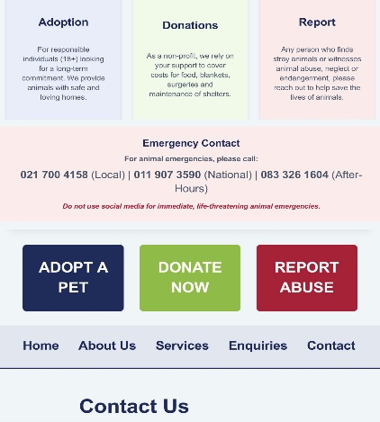

Typography
A simple sans-serif font stack consisting of Segoe UI and Arial will be used because it is easy to read across different devices. Headings will be large and bold to make them stand out, while normal text will be used for content. Line height will be set to 1.4 to keep text compact and readable. Different font sizes will also help to separate headings from body text (Web.MIT, n.d.).
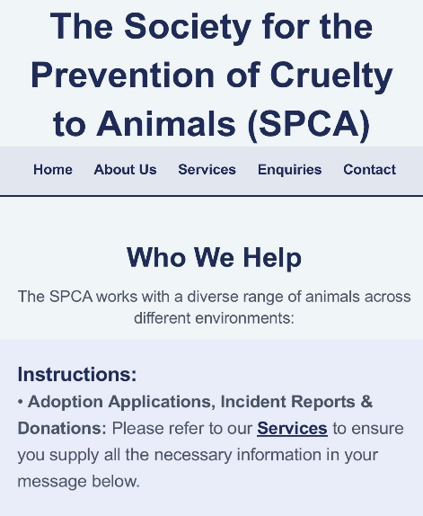

Layout and Design
The layout will be clean and organised so that users do not feel overwhelmed. The page will be divided into clear sections such as the header, navigation menu, content area and footer. Information will be grouped into cards to clearly separate sections. Images will be used where needed to create an emotional connection with users. Important buttons will be placed in visible positions so that users can quickly take action (Devoq, 2024).
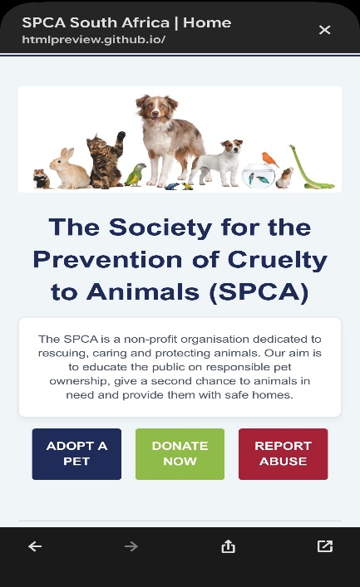

User Experience Considerations
The website will focus on being easy to use. Navigation will be straightforward, allowing users to quickly find what they are looking for. Important actions like adopting, donating and reporting will be easy to access. The site will be designed to work well on any device (AltaVista, 2025).

Low-fidelity Wireframes
Below is an image to visualise the website’s layout and information hierarchy using low-fidelity wireframes:
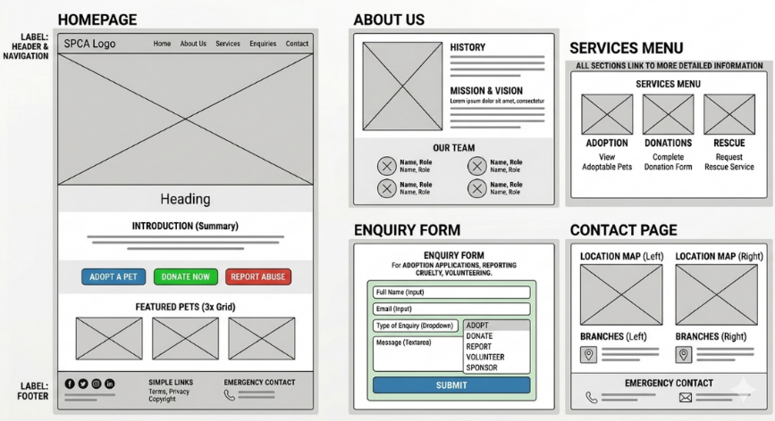

Technical Requirements

Domain Name
A domain name is needed so that users can easily access the website online (Cloudflare, 2026). The proposed domain name is “spcawelfare.org.za” because it is simple and relevant to the organisation.

Hosting
Hosting is required to store the website files and make the site accessible on the internet (HOSTAFRICA, 2024). The website will be built using Visual Studio Code and managed through GitHub. GitHub Pages will then be used to publish the website online.

Programming Language and Framework
The website will use HTML, CSS and JavaScript. HTML will structure the pages, CSS will handle the design and layout and JavaScript will add interactivity such as forms and user actions (Mozilla, 2026).

Timeline and Milestones
Activity | Feb 2026 | Mar 2026 | Apr 2026 | May 2026 | June 2026
Planning Project
Research and Content Gathering
Create HTML Structure - Part 1
Organise your Files
Apply CSS Styling - Part 2
Create a Responsive Design
Optimise for User Experience
Implement JavaScript - Part 3
Optimise for SEO
Create Functional Forms
Integrate External Services

Budget

Development
Development would typically cost between R3000 and R7000 as a once-off payment if done by a freelancer or junior developer (ProCompare, n.d.).

Domain
A domain name would cost between R100 and R200 per year, depending on the provider (HOSTAFRICA, 2026).

Hosting
GitHub Pages is the development host and is free, however for a production server later the cost for a small website can range between R100 and R300 per month (Hostigo, 2026).

Maintenance
Ongoing maintenance, such as updates and small fixes, can cost between R500 to R5000 per month, depending on how much work is required (Allanux Web, 2026).

References
- Adobe. (2025) The role of KPIs in modern web performance. Available at: https://business.adobe.com/blog/basics/kpi (Accessed: 19 April 2026).
- Allanux Web. (2026) Website maintenance costs in South Africa: 2026 pricing guide. Available at: https://www.allanuxweb.com/blog/website-maintenance-costs (Accessed: 19 April 2026).
- AltaVista. (2025) Why mobile-friendly websites are crucial in 2025. Available at: https://www.altavistasp.com/why-mobile-friendly-websites-are-crucial-in-2025/ (Accessed: 19 April 2026).
- Cape of Good Hope SPCA. (2026) Welcome to the Cape of Good Hope SPCA. Available at: https://capespca.co.za/ (Accessed: 19 April 2026).
- Cloudflare. (2026) What is a domain name? Domain names vs URLs. Available at: https://www.cloudflare.com/learning/dns/glossary/what-is-a-domain-name/ (Accessed: 19 April 2026).
- Devoq. (2024) The essentials of modern web design: UI/UX best practices for 2024. Available at: https://devoq.medium.com/the-essentials-of-modern-web-design-ui-ux-best-practices-for-2024-f2965e65de10 (Accessed: 19 April 2026).
- HOSTAFRICA. (2024) Web hosting vs domain name: What you need to know. Available at: https://hostafrica.co.za/blog/domains/domain-basics/domain-vs-hosting/ (Accessed: 19 April 2026).
- HOSTAFRICA. (2026) Domains. Available at: https://hostafrica.co.za/domains/ (Accessed: 19 April 2026).
- Hostigo. (2026) Web hosting South Africa. Available at: https://hostigo.co.za/ (Accessed: 19 April 2026).
- Indeed. (2025) 15 website improvement tips. Available at: https://www.indeed.com/career-advice/career-development/improvement-of-website (Accessed: 19 April 2026).
- Jelly Design Studio. (2025) 5 must-have service-based website pages to build trust and book clients. Available at: https://jellydesignstudio.com/service-based-website-page/ (Accessed: 19 April 2026).
- Mozilla. (2026) MDN Web Docs. Available at: https://developer.mozilla.org/en-US/ (Accessed: 19 April 2026).
- Nicola. (2025) 5 essential pages every small business website needs. Available at: https://www.webador.com/blog/5-essential-pages-every-small-business-website-needs/ (Accessed: 19 April 2026).
- NSPCA. (2026) Our history and the fight against cruelty. Available at: https://nspca.co.za/ (Accessed: 19 April 2026).
- ProCompare. (n.d.) How much does website development cost? Available at: https://www.procompare.co.za/prices/web-design/website-development (Accessed: 19 April 2026).
- SPCA Vereeniging & Vanderbijlpark. (2025) Home. Available at: https://spca-ver.co.za/ (Accessed: 19 April 2026).
- SPCA International. (2025) Pet rescue, animal shelters, adopt a pet. Available at: https://www.spcai.org/ (Accessed: 19 April 2026).
- Web.MIT. (n.d.) Safe web fonts. Available at: https://web.mit.edu/jmorzins/www/fonts.html (Accessed: 19 April 2026).
- Wikipedia Contributors. (2026) Society for the Prevention of Cruelty to Animals. Available at: https://en.wikipedia.org/wiki/Society_for_the_Prevention_of_Cruelty_to_Animals (Accessed: 19 April 2026).

